**Experiment - 1.4(b)**

**Student Name: Milan Sharma UID: 23MAI10003**

**Branch: ME – CSE - AIML Section/Group: MAI – 1 (A)**

**Semester: 1st Date of Performance: 29 Aug 2023**

**Subject Name: Python Programming Subject Code: 23 CSH 623**

1. **Aim of the Experiment :**

Write a python program to implement a calculator.

1. **Objective of the Experiment :**

To illustrate the usage of different functions and if else statements

1. **Algorithm/ Steps for Experiment**

* User choose the desired operation.Options 1, 2, 3 and 4 are valid.
* Two numbers are taken and anif…elif…else branching is used to execute a particular section.
* Usingfunctions add(), subtract(), multiply() and divide() evaluate respectiveoperations.

1. **Code for Experiment :**

def add(x, y):

return x + y

def subtract(x, y):

return x - y

def multiply(x, y):

return x * y

def divide(x, y):

return x / y

print("Select operation.")

print("1.Add")

print("2.Subtract")

print("3.Multiply")

print("4.Divide")

while True:

choice = input("Enter choice(1/2/3/4): ")

if choice in ('1', '2', '3', '4'):

num1 = float(input("Enter first number: "))

num2 = float(input("Enter second number: "))

if choice == '1':

print(num1, "+", num2, "=", add(num1, num2))

elif choice == '2':

print(num1, "-", num2, "=", subtract(num1, num2))

elif choice == '3':

print(num1, "*", num2, "=", multiply(num1, num2))

elif choice == '4':

print(num1, "/", num2, "=", divide(num1, num2))

break

else:

print("Invalid Input")

1. **Result/Output :**

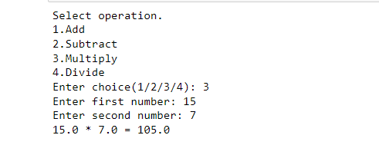

**Learning outcomes (What I have learnt):**

1. Learnt the use of def function.
2. Learnt the use of break statement